What are the physical media available for Ethernet, Fast Ethernet and Gigabit Ethernet? Also note their maximum segment length.
Ethernet Type | Standard | Medium Used | Max Segment Length
Classic Ethernet (10 Mbps) | 10Base5 | Thick Coaxial Cable | 500 m
 | 10Base2 | Thin Coaxial Cable | 185 m
 | 10BaseT | UTP Cat 3/5 Copper | 100 m
Fast Ethernet (100 Mbps) | 100BaseTX | UTP Cat 5e Copper | 100 m
 | 100BaseFX (MM) | Multimode Fiber | 2 km
 | 100BaseFX (SM) | Single-mode Fiber | 20 km
Gigabit Ethernet (1000 Mbps) | 1000BaseT | UTP Cat 5e/6 Copper | 100 m
 | 1000BaseSX | Multimode Fiber (Short-reach) | 275 m
 | 1000BaseLX (MM) | Multimode Fiber | 512 m
 | 1000BaseLX (SM) | Single-mode Fiber (Long-reach) | 20 km
 | 1000BaseLH | Single-mode Fiber (Long-haul) | 80 km

What leads to Fast Ethernet?
The transition and development that led to Fast Ethernet can be summarized through the following sequential points based on your course notes:
- Sustained Growth and Network Crowding: In the early days of networking, Classic Ethernet (operating at 10 Mbps) offered sufficient speeds. However, as more workstations and computers were connected to Local Area Networks (LANs) and users began exchanging significantly larger files, the original 10 Mbps bandwidth became a major bottleneck.
- Failure of Ring-Based Optical Competitors: Before Fast Ethernet was standardized, companies attempted to solve the speed crisis by designing faster, specialized network architectures based on ring-shaped optical cables, such as FDDI (Fiber Distributed Data Interface) and Fiber Channel. While they successfully utilized light signals to transmit data quickly, they completely failed to achieve mainstream popularity for desktop computers due to three primary barriers:
  - Complex Network Management: Managing and troubleshooting the ring infrastructure was highly complicated.
  - High Chip Complexity: The integrated circuits and chips required to run these protocols were overly complex to design.
  - Exorbitant Cost: The specialized equipment was far too expensive for widespread commercial deployment.
- The Strategic Choice to Upgrade Ethernet: Because of the failures and high costs of FDDI and Fiber Channel, the networking industry collectively decided to improve the existing Ethernet standard rather than adopting an entirely new, complex technology.
- Preservation of the Core Architecture: This design philosophy directly resulted in Fast Ethernet (100 Mbps). It succeeded because it intentionally retained Classic Ethernet's simple, inexpensive, and well-understood foundational rules—specifically reusing the exact same CSMA/CD (Carrier Sense Multiple Access with Collision Detection) media access protocol and the same frame/packet format. This allowed organizations to scale their bandwidth tenfold while fully preserving their existing software systems and engineering experience.

What are the Ethernet, Fast Ethernet and Gigabit Ethernet physical media types? Write down their maximum segment length.
1. Classic Ethernet (10 Mbps)
Classic Ethernet operates at 10 Mbps and uses various coaxial, twisted-pair, and fiber optic options:
- 10Base5: Uses Thick coaxial cable in a bus topology with a maximum segment length of 500 meters.
- 10Base2: Uses Thin coaxial cable in a bus topology with a maximum segment length of 185 meters.
- 10BaseT: Uses UTP Category 3/5 copper cable in a tree (star) topology with a maximum segment length of 100 meters.
- 10BaseFL: Uses Multimode or Single-mode fiber optic links in a tree topology.
2. Fast Ethernet (100 Mbps)
Fast Ethernet upgrades the bandwidth to 100 Mbps using copper and fiber media:
- 100BaseTX: Uses UTP Category 5e copper cable with a maximum segment length of 100 meters.
- 100BaseFX (Multimode): Uses Multimode fiber optic cable with a maximum segment length of 2 kilometers (2 km).
- 100BaseFX (Single-mode): Uses Single-mode fiber optic cable with a maximum segment length of 20 kilometers (20 km).
3. Gigabit Ethernet (1000 Mbps / 1 Gbps)
Gigabit Ethernet provides 1 Gbps of bandwidth across copper, short-reach fiber, and long-reach fiber standards:
- 1000BaseT: Uses UTP Category 5e or Category 6 copper cable with a maximum segment length of 100 meters.
- 1000BaseSX: Uses Multimode fiber (short reach) with a maximum segment length of 275 meters.
- 1000BaseLX (Multimode): Uses Multimode fiber (long reach) with a maximum segment length of 512 meters.
- 1000BaseLX (Single-mode): Uses Single-mode fiber (long reach) with a maximum segment length of 20 kilometers (20 km).
- 1000BaseLH: Uses Single-mode fiber (long haul) with a maximum segment length of 80 kilometers (80 km).

Ethernet Standard Generation | Media Standard Name | Physical Media / Cable Type Used | Maximum Segment Length
Classic Ethernet  (10 Mbps) | 10Base5  10Base2  10BaseT  10BaseFL | Thick coaxial cable  Thin coaxial cable  UTP Cat 3/5 copper cable  Multimode/Single-mode fiber | 500 m  185 m  100 m  Fiber optic link
Fast Ethernet  (100 Mbps) | 100BaseTX  100BaseFX (MM)  100BaseFX (SM) | UTP Cat 5e copper  Multimode fiber  Single-mode fiber | 100 m  2 km  20 km
Gigabit Ethernet  (1000 Mbps) | 1000BaseT  1000BaseSX  1000BaseLX (MM)  1000BaseLX (SM)  1000BaseLH | UTP Cat 5e/Cat 6 copper  Multimode fiber  Multimode fiber  Single-mode fiber  Single-mode fiber | 100 m  275 m  512 m  20 km  80 km
Explain Non-adaptive & Adaptive routing algorithm.
Routing algorithms are broadly categorized into two main types based on how they make their decisions: Non-Adaptive (Static) Routing and Adaptive (Dynamic) Routing.
1. Non-Adaptive (Static) Routing
Definition
Non-adaptive routing algorithms, commonly known as static routing, choose paths and routing decisions in advance. They do not factor in the current live traffic or network topology changes while the network is actively running.
How it Works
- Pre-calculated Offline: The optimal route between every pair of routers is calculated beforehand, completely offline. This is typically done by a network administrator or a specialized network planning tool.
- Boot-time Loading: These fixed, predetermined routes are loaded directly into each router's routing table when the network boots up.
- Analogy: It functions like a fixed traffic light schedule that changes colors at exact intervals, completely ignoring whether the road is empty or heavily gridlocked.
Key Characteristics
- Advantages: It is highly simple to implement and introduces zero extra computational processing overhead on the routers while the network is running.
- Disadvantages: It is completely rigid; it cannot dynamically react to network congestion, broken links, or shifting traffic patterns.
- Core Examples: Shortest Path (when computed strictly offline), Flooding, and Flow-based routing.
2. Adaptive (Dynamic) Routing
Definition
Adaptive routing algorithms, also called dynamic routing, continuously change and optimize their routing decisions on the fly while the network is running.
How it Works
These algorithms constantly adjust their tables based on real-time feedback from the network, reacting to topology changes (like a link going down) or current traffic levels. Dynamic algorithms differ from one another based on three key parameters:
- Information Source: Where they collect their data from—some look only at local information at the router itself, some gather metrics from neighboring (adjacent) routers, and others collect data from all routers across the entire network.
- Update Trigger (When routes change): Routes can change at regular fixed time intervals ($△T$ seconds), only when the traffic load shifts, or exclusively when the network topology changes.
- Optimized Metric: What specific parameter they are trying to optimize, such as physical distance, minimum number of hops, or estimated transit delay time.
Key Characteristics
- Advantages: Highly resilient; it automatically reroutes packets around failed links or heavily congested paths.
- Disadvantages: Introduces a much higher processing overhead because routers must constantly compute paths and exchange control packets.
- Core Examples: Distance Vector Routing, Link State Routing (OSPF), and Hierarchical routing.

Feature / Aspect | Static (Non-Adaptive) Routing | Dynamic (Adaptive) Routing
Decision Basis | Computed completely offline, in advance. | Computed continuously using live, current network conditions.
Reaction to Failures/Traffic | No, cannot adjust if a link drops or clogs. | Yes, automatically recalculates paths around problems.
Processing Overhead | Low; no ongoing computational cost. | Higher; requires active CPU cycles for continuous calculation.
Metrics Used | Fixed administrative weights or offline costs. | Dynamic metrics like link load, delay, bandwidth, or hop count.
Typical Protocols | Manual Static Routes, Flooding. | RIP (Distance Vector), OSPF / IS-IS (Link State).

What do you mean by the optimality principle and sink tree?
The Optimality Principle and Sink Trees are foundational theoretical concepts used as benchmarks to evaluate how effectively a routing algorithm determines the best paths in a network.
1. The Optimality Principle
Definition
The optimality principle is a general, mathematical rule regarding ideal (optimal) routing paths that remains true regardless of the network's physical layout (topology) or its current traffic conditions.
Core Statement
If router $J$ lies on the optimal path from router $I$to router $K$, then the optimal path from $J$to $K$also follows that very same route.
Why It Matters
This principle acts as a strict standard or benchmark. Network engineers use it to verify whether a routing algorithm is genuinely producing the most efficient, mathematically optimal paths through a network. If a sub-path within a chosen route violates this principle, the overall path cannot be optimal.
2. Sink Trees
Definition
A Sink Tree is a collection of all the optimal routes from every single router in a network to one specific destination router.
When you gather these optimal paths and draw them together, they naturally form a tree structure where the destination router sits at the very base, or the "root".
Key Characteristics
- Path Metrics: The distance metric used to calculate a sink tree is very often measured simply by the number of hops (how many routers a packet must cross).
- Not Always Unique: A sink tree is not always unique to a destination. It is entirely possible for multiple, different trees to exist within the same network if they have the exact same total path lengths to the destination.
- The Ultimate Goal: The primary objective of all dynamic routing algorithms is to successfully discover and maintain efficient sink trees for every single router operating within the network.
- Analogy: Think of a sink tree like a blueprint of the "best roads home" from every neighborhood in a city. When you map all those optimal roads together, they form a tree shape that funnels traffic from every starting point toward that one final home destination.

What do you mean by routing metrics? Explain with figure and example.
A routing metric is a cost value assigned to a network path. A routing algorithm uses this value to choose the best path.
When a router has many paths to reach a destination, it adds up the costs of all links along each path. The router then chooses the path with the lowest total metric.

Different routing protocols use different types of metrics:
- Hop Count (Path Length): The total number of links or routers a packet must cross.
- Delay: The total time it takes for a packet to travel along the link in milliseconds.
- Bandwidth: The total data capacity of the link.
- Load: How busy or crowded a link currently is with traffic.
- Reliability: How safe the link is from failing or dropping data.

Consider the network topology above. A packet needs to travel from Router A to Router M. There are two possible paths:
Case 1: Using Hop Count as the Metric
If the protocol chooses paths based on Hop Count, it looks for the fewest routers:
- Path 1 (A → B → M): This path takes 2 hops.
- Path 2 (A → C → F → E → M): This path takes 4 hops.
The Choice: The router chooses Path 1 because 2 hops is smaller than 4 hops.
Case 2: Using Delay as the Metric
If Path 1 is very crowded with background traffic, its links become slow. The Delay changes:
- Path 1 (A → B → M): High traffic makes the delay 50 ms per link. Total delay = $50\text{ ms}+50\text{ ms}=100\text{ ms}$.
- Path 2 (A → C → F → E → M): High-speed fiber lines make the delay 10 ms per link. Total delay = $10\text{ ms}+10\text{ ms}+10\text{ ms}+10\text{ ms}=40\text{ ms}$.
The Choice: The router chooses Path 2 because a total delay of 40 ms is faster than 100 ms.

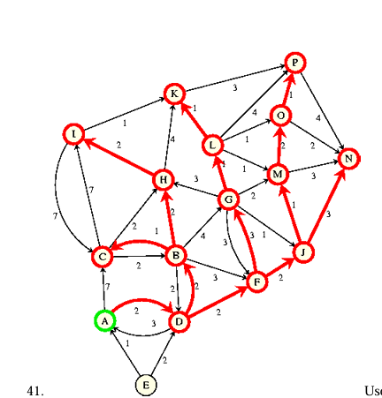
Use shortest path algorithm to find shortest path from A to M

Step | Working  Node | A | B | C | D | E | F | G | H | I | J | K | L | M
0 | Initial | [0, -] | [$∞$,-] | [$∞$,-] | [$∞$,-] | [$∞$,-] | [$∞$,-] | [$∞$,-] | [$∞$,-] | [$∞$,-] | [$∞$,-] | [$∞$,-] | [$∞$,-] | [$∞$,-]
1 | A | [0, -] | [$∞$,-] | [7, A] | [2, A] | [$∞$,-] | [$∞$,-] | [$∞$,-] | [$∞$,-] | [$∞$,-] | [$∞$,-] | [$∞$,-] | [$∞$,-] | [$∞$,-]
2 | D | [0, -] | [4, D] | [7, A] | [2, A] | [$∞$,-] | [4, D] | [$∞$,-] | [$∞$,-] | [$∞$,-] | [$∞$,-] | [$∞$,-] | [$∞$,-] | [$∞$,-]
3 | B | [0, -] | [4, D] | [5, B] | [2, A] | [$∞$,-] | [4, D] | [8, B] | [6, B] | [$∞$,-] | [$∞$,-] | [$∞$,-] | [$∞$,-] | [$∞$,-]
4 | F | [0, -] | [4, D] | [5, B] | [2, A] | [$∞$,-] | [4, D] | [7, F] | [6, B] | [$∞$,-] | [6, F] | [$∞$,-] | [$∞$,-] | [$∞$,-]
5 | C | [0, -] | [4, D] | [5, B] | [2, A] | [$∞$,-] | [4, D] | [7, F] | [6, B] | [12, C] | [6, F] | [$∞$,-] | [$∞$,-] | [$∞$,-]
6 | H | [0, -] | [4, D] | [5, B] | [2, A] | [$∞$,-] | [4, D] | [7, F] | [6, B] | [8, H] | [6, F] | [10, H] | [$∞$,-] | [$∞$,-]
7 | J | [0, -] | [4, D] | [5, B] | [2, A] | [$∞$,-] | [4, D] | [7, F] | [6, B] | [8, H] | [6, F] | [10, H] | [$∞$,-] | [7, J]

Final Result
- Shortest Path: A → D → F → J → M
- Total Minimum Cost: 7

State the steps of the shortest path algorithm.
Dijkstra's Shortest Path Algorithm Steps
- Step 1: Initialize the Source Node
  - Mark the starting (source) node as permanent. Its final shortest distance is fixed at 0.
  - Set this source node as your current working node.
- Step 2: Initialize All Other Nodes
  - Set the tentative (temporary) distance to every other node in the network to infinity ($∞$).
- Step 3: Update Neighbor Distances
  - Look at all temporary neighbor nodes directly connected to your current working node.
  - Calculate a new distance to each neighbor:
$$\text{New Distance}=\left(\text{Distance to working node}\right)+\left(\text{Link cost from working node to neighbor}\right)$$
  - If this new distance is smaller than the neighbor's current distance, replace it with the new lower value. Record the working node as the path's previous step.
- Step 4: Select the Next Working Node
  - Look at all remaining temporary nodes across the entire network.
  - Choose the node with the smallest tentative distance.
  - Mark this chosen node as permanent and make it your new working node.
- Step 5: Repeat Until Complete
  - Repeat Step 3 and Step 4 until every single node in the graph is marked permanent. Once a node is permanent, its shortest path and distance from the source are final and will never change.

Explain with figure the count-to-infinity problem in DVR algorithm.
The Count-to-Infinity problem is a major weakness in Distance Vector Routing. It happens when a link or a router completely fails. Because routers only share data with their immediate neighbors, they cannot quickly see that a destination is now unreachable. Instead, they create a routing loop and slowly count upward toward a maximum value (infinity). This causes very slow convergence.

Consider five routers connected in a straight line topology: A — B — C — D — E.
Initially, all routers have correct paths to reach A. The hop count from each router (B, C, D, E) to A is 1, 2, 3, 4 respectively.
Step 1: The Link Fails
- The link between A and B breaks.
- B can no longer reach A directly. B sets its direct cost to A as infinity ($∞$).
Step 2: The Routing Exchange (The Mistake)
- At the next routing update, C shares its table with B. C claims: "I can reach A in 2 hops."
- B does not know that C's path to A actually goes through B itself.
- B thinks: "I can reach C in 1 hop, and C can reach A in 2 hops, so I can reach A via C in $1+2=3$ hops." B updates its table to 3 hops.
Step 3: The Upward Count
- On the next exchange, C sees that B now claims a distance of 3 hops to A.
- C updates its distance to: $1+3=4\text{ hops}$.
- Then, B sees C's new value and updates its distance to 5 hops.
Step 4: Reaching Infinity
This wrong loop continues slowly across all routers. The values keep climbing until they hit a predefined maximum number (for example, 16 in the RIP protocol). Only when it hits that maximum limit do the routers finally understand that A is completely unreachable.

Briefly explain the steps of Link State Routing.
Link State Routing is a dynamic routing algorithm where every router builds a complete map of the network topology and independently finds the shortest path.
Here are the five steps that every router performs:
The 5 Steps of Link State Routing
- Step 1: Discover Neighbors
  - When a router boots up, it sends a special HELLO packet out on its lines.
  - The routers at the other end reply with their addresses so everyone learns who their direct neighbors are.
- Step 2: Measure Line Cost
  - The router measures the delay (one-way transit time) to each neighbor by sending an ECHO packet.
  - The neighbor replies immediately. The router takes half of the round-trip time as the cost.
  - Note: Only transmission delay is measured; queue waiting time is ignored to prevent the paths from oscillating.
- Step 3: Build Link State Packets (LSP)
  - The router creates an LSP containing its identity, a sequence number, an age (TTL) value, and a list of its direct neighbors with their measured costs.
  - This packet is created at regular time intervals or whenever a major event happens (like a link going down).
- Step 4: Distribute LSPs (Selective Flooding)
  - The router sends its LSP to all other routers in the network using selective flooding.
  - Each router forwards received LSPs out on all lines except the one it arrived on. Routers use the sequence numbers to safely discard duplicate or old out-of-date packets.
- Step 5: Compute New Routes
  - Once a router collects LSPs from every router, it has a complete, identical map of the entire network topology.
  - The router runs Dijkstra's algorithm locally on this map to find the shortest path from itself to all destinations and updates its routing table.

Why do we need interconnecting networks and how to do that? How do the available networks differ from each other?
- No Single Global Network: No single network technology can physically or practically connect every computer in the world.
- Diverse Local Technologies: Different organizations, regions, and businesses build their own independent networks using different technologies that fit their specific needs.
- The Goal of Internetworking: We need internetworking to connect these separate, distinct networks together so they can function smoothly as one large, unified super-network (an internet). This allows any user on any network to communicate and share data with users on another network, regardless of the underlying technology they use.

When trying to connect different networks, engineers face the challenge that networks differ across many structural and operational layers. Key differences include:
- Services Offered: Some networks use connection-oriented services, while others use connectionless services.
- Protocols Used: Networks run completely different sets of rules and protocols, such as IP, IPX, SNA, ATM, MPLS, or AppleTalk.
- Addressing Schemes: Networks vary in their address sizes, formats, and how those logical addresses are assigned to devices.
- Packet Size Limits: Different networks have different maximum packet sizes (Maximum Transmission Units or MTUs) that they can safely carry inside their frames.
- Feature Support: Some networks support broadcasting or multicasting features, while others completely lack these capabilities.
- Reliability and Delivery Order: Some networks guarantee reliable, in-order packet delivery, whereas others operate purely on a "best-effort" delivery basis where packets can arrive out of order or get dropped.

To connect different networks, specialized hardware components are used. These devices operate at different layers of the OSI reference model:
- Repeaters and Hubs (Layer 1 - Physical Layer): These devices simply amplify or copy electrical signals from one cable segment to another.
  - They do not read hardware or logical addresses. They are only used to extend the physical reach of a single network segment, not to connect truly different networks.
- Bridges and Switches (Layer 2 - Data Link Layer): These devices read and understand hardware MAC addresses.
  - A switch intelligently forwards frames only to the specific port where the destination device resides. They can perform minor protocol translations (such as bridging an Ethernet segment to a Wi-Fi segment), but they still keep devices within a localized structure.
- Routers (Layer 3 - Network Layer): Routers are the true devices used for internetworking. They read logical IP addresses instead of hardware MAC addresses to make path decisions.
  - A router can successfully join completely different networks that use entirely different lower-layer standards and packet sizes. Multiprotocol routers can even handle multiple different network-layer protocols at the same time to ensure global communication.

Why do we need packet fragmentation? Do fragmentation for the given network.
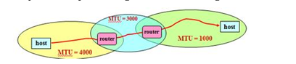
Packet Fragmentation is needed because different networks have different Maximum Transmission Unit (MTU) sizes. If an IP packet is larger than the MTU of the next network, the router divides it into smaller fragments so that each fragment can pass through the network. Each fragment contains its own 20-byte IP header.
Given
- Original IP Datagram = 4000 bytes
- IP Header = 20 bytes
- Data = 3980 bytes

Network 1 (MTU = 4000)
Since 4000 ≤ 4000, no fragmentation is needed.
Fragment | Header | Data | Total Length | MF | Offset
F1 | 20 | 3980 | 4000 | 0 | 0

Network 2 (MTU = 3000)
Maximum Data = MTU − Header
= 3000 − 20 = 2980 bytes
Total Data = 3980 bytes
Fragment | Header | Data | Total Length | MF | Offset
F1 | 20 | 2980 | 3000 | 1 | 0
F2 | 20 | 1000 | 1020 | 0 | 2980

Network 3 (MTU = 1000)
Maximum Data = MTU − Header
= 1000 − 20 = 980 bytes
Fragmenting F1 (Data = 2980 bytes)
Fragment | Header | Data | Total Length | MF | Offset
F1a | 20 | 980 | 1000 | 1 | 0
F1b | 20 | 980 | 1000 | 1 | 980
F1c | 20 | 980 | 1000 | 1 | 1960
F1d | 20 | 40 | 60 | 1 | 2940
Fragmenting F2 (Data = 1000 bytes)
Fragment | Header | Data | Total Length | MF | Offset
F2a | 20 | 980 | 1000 | 1 | 2980
F2b | 20 | 20 | 40 | 0 | 3960

Final Fragments
Final Fragment | Header | Data | Total Length | MF | Offset
F1a | 20 | 980 | 1000 | 1 | 0
F1b | 20 | 980 | 1000 | 1 | 980
F1c | 20 | 980 | 1000 | 1 | 1960
F1d | 20 | 40 | 60 | 1 | 2940
F2a | 20 | 980 | 1000 | 1 | 2980
F2b | 20 | 20 | 40 | 0 | 3960
Verification
Total Data:
980 + 980 + 980 + 40 + 980 + 20 = 3980 bytes
This equals the original data size (3980 bytes), so the fragmentation is correct.

What are the fragmentation-related fields? Explain.
The 4 Fragmentation-Related Fields
1. Total Length Field
- Purpose: Indicates the total size of that specific, individual fragment.
- Explanation: It measures the size of the entire IP packet in bytes, which includes both the 20-byte IP header and the actual data payload carried inside that particular piece.
2. Identification Field
- Purpose: Groups related fragments together.
- Explanation: The sending host assigns a unique identification number to the original unsplit packet. When a router fragments that packet, it copies this exact same identification number into the header of every single piece. This allows the receiving destination to know which incoming fragments belong to the same original packet.
3. Flags Field
The flags field consists of control bits, two of which are critical for managing fragmentation:
- Don't Fragment (DF) Flag: If $DF=1$, it explicitly instructs routers that they must not fragment the packet. If the packet reaches a link where it is too large to fit through the outgoing MTU, the router is forced to drop it and send an error message back to the sender. If $DF=0$, routers are permitted to break the packet apart if needed.
- More Fragments (MF) Flag: This bit acts as a marker to let the receiver know if there are more pieces coming. If $MF=1$, it means more fragments belonging to this packet will follow. If $MF=0$, it indicates that this piece is the last (or only) fragment of the original packet, signaling the receiver to begin reassembly.
4. Fragment Offset Field
- Purpose: Identifies the correct position of the fragment data inside the original unsplit packet.
- Explanation: Because fragments can travel along different physical network paths, they often arrive at the final destination completely out of order. The offset field acts as a structural guide or index.
- Important Rule: In standard networking protocols, the offset value is measured strictly in units of 8-byte blocks rather than individual bytes. For example, an offset value of 122 means the data payload in this fragment starts exactly at byte position $122×8=976$of the original payload data.

What are the network layer protocols? What are purposes of using an IP address?
Network Layer Protocols
The main network layer protocols are:
- IP (Internet Protocol): Delivers data from the source host to the destination host.
- ARP (Address Resolution Protocol): Finds the MAC address from an IP address.
- RARP (Reverse Address Resolution Protocol): Finds the IP address from a MAC address.
- ICMP (Internet Control Message Protocol): Reports network errors and sends status messages.
- IGMP (Internet Group Management Protocol): Manages multicast communication between hosts and routers.
Purposes of Using an IP Address
- Identifies every device uniquely on a network.
- Helps deliver data from the source to the correct destination.
- Supports host-to-host communication over different networks.
- Helps routers find the correct path for packet delivery.
- Provides logical addressing for communication across the Internet.

Why does the delivery of a packet need two levels of addressing (IP and MAC)?
Answer:
Packet delivery needs two levels of addressing because IP address and MAC address perform different jobs.
- IP address provides logical addressing and identifies the source and destination across different networks.
- MAC address provides physical addressing and delivers the packet to the correct device within the local network.
- A packet may travel through different physical networks, so IP is used for end-to-end communication, while MAC is used for local delivery at each hop.
- Therefore, both IP address and MAC address are necessary for successful packet delivery.

Explain static and dynamic mapping. State their limitations.
Answer:
Static Mapping
Static mapping is a method where the IP address and MAC address are stored in a fixed table on every computer. The mapping remains the same until it is changed manually.
Limitation:
- The table must be updated manually whenever the MAC address changes, making it difficult to manage.
Dynamic Mapping
Dynamic mapping is a method where the computer finds the address automatically when needed using ARP, RARP, or DHCP. It does not require a fixed address table.
Limitation:
- It depends on network communication, so extra request and reply messages are needed before data transmission.

Show with figure that ARP request is broadcast and reply is unicast.
Answer:
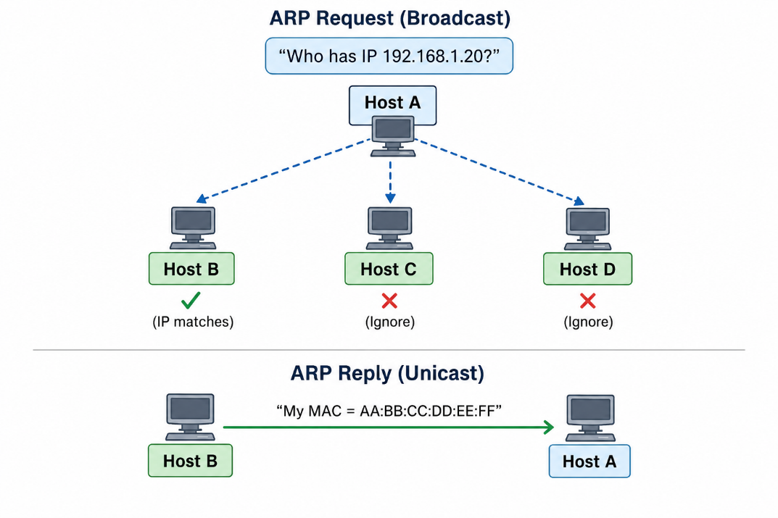
When a host wants to know the MAC address of a destination, it sends an ARP Request as a broadcast to all devices in the local network. Only the device with the matching IP address sends an ARP Reply as a unicast directly to the sender.
Show ARP packet formation and encapsulation. What are the 4 cases of using ARP?
Answer:
ARP Packet Formation
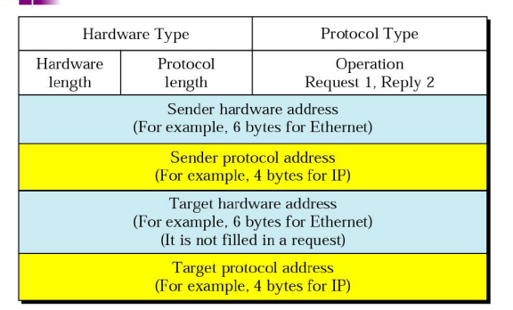
An ARP packet is used to map an IP address to a MAC address. It contains information about the sender, the target, and the operation type (Request or Reply).

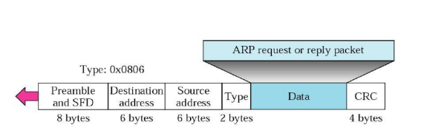
ARP Encapsulation
Before transmission, the ARP packet is encapsulated inside an Ethernet frame. The EtherType field is set to 0x0806, which indicates that the payload contains an ARP packet.

Four Cases of Using ARP
- Host → Host (Same Network): ARP finds the destination host's MAC address.
- Host → Router (Different Network): ARP finds the MAC address of the default router.
- Router → Router: ARP finds the MAC address of the next-hop router.
- Router → Host: ARP finds the destination host's MAC address.

A host with IP address 130.23.3.20 and physical address B23455102210 has a packet to send to another host with IP address 130.23.43.25 and physical address A46EF45983AB. The two hosts are on the same Ethernet network. Show the ARP request and reply packets encapsulated in Ethernet frames.
Answer:
Since both hosts are on the same Ethernet network, the sender first broadcasts an ARP Request to learn the destination's MAC address. The destination host then sends an ARP Reply directly to the sender with its MAC address. Both ARP packets are encapsulated inside Ethernet frames.
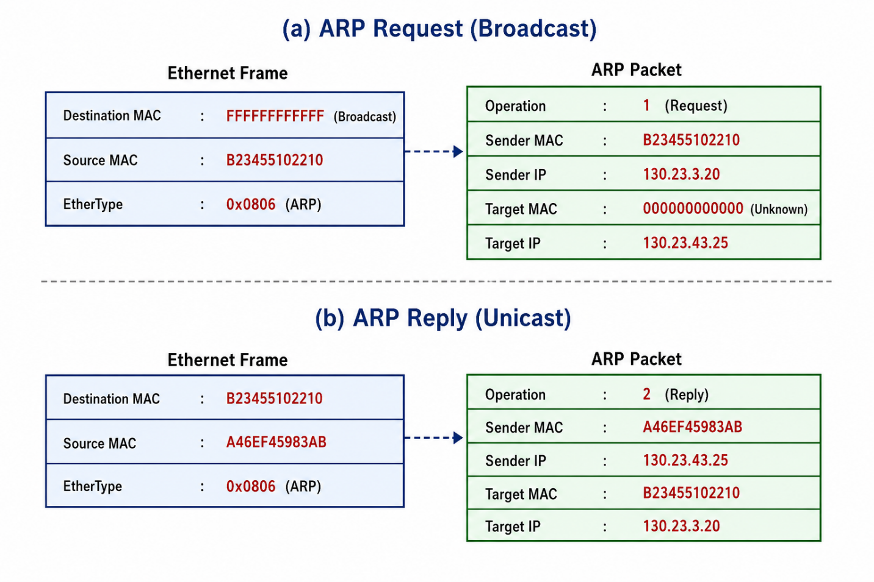
- ARP Request → Broadcast (Destination MAC = FFFFFFFFFFFF)
- ARP Reply → Unicast (Destination MAC = Sender's MAC)
- EtherType = 0x0806 indicates that the Ethernet frame carries an ARP packet.

Show RARP packet formation and encapsulation.
Answer:
RARP Packet Formation
A RARP packet is used to find the IP address of a host from its MAC address. It has the same fields as an ARP packet, but the Operation field is 3 for Request and 4 for Reply.
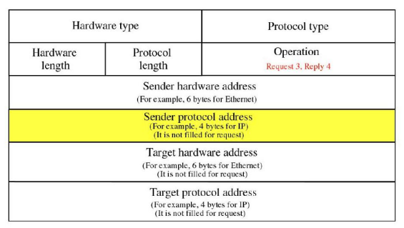

RARP Encapsulation
Before transmission, the RARP packet is encapsulated inside an Ethernet frame. The EtherType field is 0x8035, which indicates that the frame carries a RARP packet.
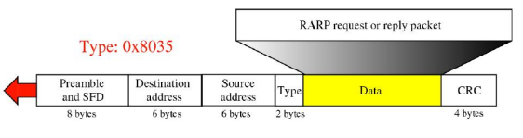

Explain using figure the four cases of using ARP.
Answer:
ARP is used to find the MAC address of the next device before sending data on a local network. There are four cases where ARP is used.
Case 1: Host → Host (Same Network)
Host A --------ARP--------> Host B
Finds Host B's MAC
Case 2: Host → Router (Different Network)
Host A --------ARP--------> Router
Finds Router's MAC
Case 3: Router → Router
Router 1 -----ARP-------> Router 2
Finds Next Router's MAC
Case 4: Router → Host
Router --------ARP--------> Host
Finds Host's MAC

What is the purpose of DHCP protocol and how does it work?
Answer:
Purpose of DHCP
DHCP (Dynamic Host Configuration Protocol) automatically assigns an IP address and other network settings, such as subnet mask, default gateway, and DNS server, to a host. It replaces RARP and reduces manual network configuration.
How DHCP Works
DHCP follows these four steps:
- DHCPDISCOVER: The client broadcasts a request to find a DHCP server.
- DHCPOFFER: The server offers an available IP address.
- DHCPREQUEST: The client requests the offered IP address.
- DHCPACK: The server confirms the request and assigns the IP address.

Draw state-transition diagram for DHCP. Explain all six states.
Answer:
A DHCP client passes through six states to obtain and maintain its IP address.
State-Transition Diagram
Six States
- Initializing: The client sends DHCPDISCOVER to find a DHCP server.
- Selecting: The client receives one or more DHCPOFFER messages and selects one server.
- Requesting: The client sends DHCPREQUEST for the selected IP address.
- Bound: The client receives DHCPACK and starts using the assigned IP address.
- Renewing: At 50% of the lease time, the client requests to renew the lease.
- Rebinding: At 87.5% of the lease time, if renewal fails, the client requests any DHCP server to renew the lease.

Show the DHCP message exchange between client-server.
Answer:
The DHCP client and server exchange four messages to assign an IP address.
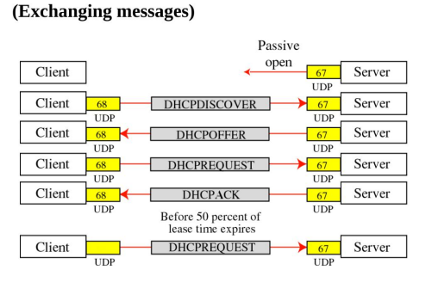
Message Description
- DHCPDISCOVER: Client searches for a DHCP server.
- DHCPOFFER: Server offers an available IP address.
- DHCPREQUEST: Client requests the offered IP address.
- DHCPACK: Server confirms the request and assigns the IP address.

Draw IPv4 and IPv6 datagram format and explain about each field briefly.
Answer:
(a) IPv4 Datagram Format
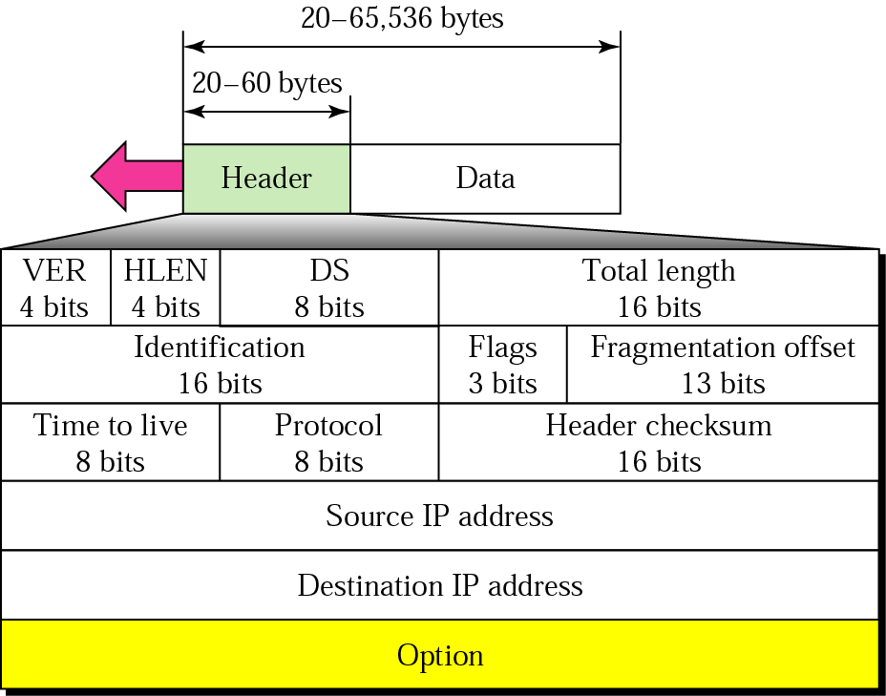
IPv4 Fields (Brief):
- VER: IP version (IPv4 = 4).
- HLEN: Header length.
- Differentiated Services: Provides Quality of Service (QoS).
- Total Length: Total size of the datagram.
- Identification: Identifies fragments of the same datagram.
- Flags: Controls fragmentation.
- Fragment Offset: Position of the fragment.
- TTL: Limits packet lifetime.
- Protocol: Identifies upper-layer protocol (TCP, UDP, etc.).
- Header Checksum: Detects header errors.
- Source IP: Sender's IP address.
- Destination IP: Receiver's IP address.
- Options: Optional control information.
- Data: Carries the actual message.

(b) IPv6 Datagram Format
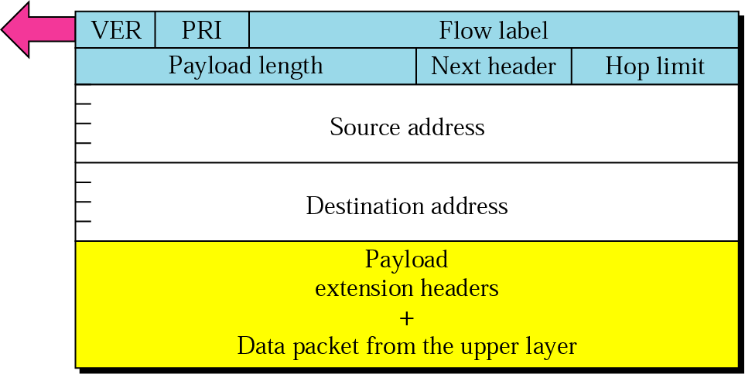
IPv6 Fields (Brief):
- VER: IP version (IPv6 = 6).
- Priority / Traffic Class: Packet priority.
- Flow Label: Identifies a data flow.
- Payload Length: Size of payload.
- Next Header: Next protocol or extension header.
- Hop Limit: Limits packet lifetime.
- Source Address: Sender's IPv6 address.
- Destination Address: Receiver's IPv6 address.
- Payload: Actual data.

Define MTU and the fields of fragmentation with appropriate figure.
Answer:
MTU (Maximum Transfer Unit)
MTU (Maximum Transfer Unit) is the maximum amount of data that a network can carry in a single frame. If a packet is larger than the MTU, it is divided into fragments.
Figure
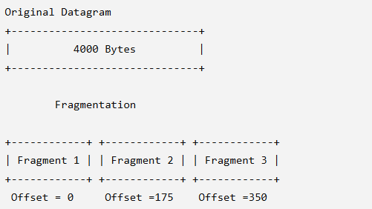
Fragmentation Fields
- Identification: Same value for all fragments of one datagram.
- Flags: Controls fragmentation.
  - D (Do Not Fragment): 1 = Do not fragment, 0 = Fragmentation allowed.
  - M (More Fragments): 1 = More fragments follow, 0 = Last fragment.
- Fragment Offset: Shows the position of the fragment in the original datagram (measured in 8-byte units).

What are the merits of IPv6 over IPv4?
Answer:
Merits of IPv6 over IPv4:
- Larger address space with 128-bit addresses.
- Simpler header for faster processing.
- Supports extension headers for new features.
- Built-in security through authentication and encryption.
- Supports Flow Label for better real-time communication.
- More flexible and scalable for future network growth.

Explain three transition strategies from IPv4 to IPv6.
Answer:
During the transition from IPv4 to IPv6, three strategies are used to allow both protocols to work together.
1. Dual Stack
A device runs IPv4 and IPv6 at the same time. It uses IPv4 or IPv6 depending on the destination address.
2. Tunneling
An IPv6 packet is encapsulated inside an IPv4 packet to travel through an IPv4 network.
3. Header Translation
The IPv6 header is converted into an IPv4 header (or vice versa) so that IPv4 and IPv6 devices can communicate.

Explain the fragmentation procedure of IPv6 packet and compare it to IPv4 fragmentation.
Answer:
IPv6 Fragmentation Procedure
In IPv6, only the source host can fragment a packet. Before sending, the source uses Path MTU Discovery to find the smallest MTU along the path. Routers do not fragment packets. If a packet is too large, the source host fragments it before transmission.
Comparison: IPv4 vs IPv6 Fragmentation
IPv4 | IPv6
Source host and routers can fragment packets. | Only the source host can fragment packets.
Routers may fragment packets during transmission. | Routers never fragment packets.
No Path MTU Discovery is required. | Uses Path MTU Discovery before sending.

Explain Home address and Care-of address, Home agent and Foreign agent with appropriate figure.
Answer:
In Mobile IP, a mobile host uses two addresses and two agents to maintain communication while moving between networks.
Definitions
- Home Address: The permanent IP address of the mobile host. It never changes.
- Care-of Address: A temporary IP address assigned in the visited network.
- Home Agent (HA): A router in the home network that keeps track of the mobile host and forwards packets.
- Foreign Agent (FA): A router in the visited network that receives forwarded packets and delivers them to the mobile host.
Figure
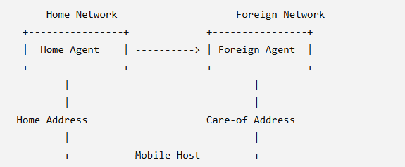

65. Explain multiplexing and de-multiplexing between network and transport layer using appropriate figure.
Answer:
Multiplexing combines data from different transport layer protocols into one IP protocol at the sender. De-multiplexing separates the received data and delivers it to the correct transport layer protocol at the receiver.
Figure
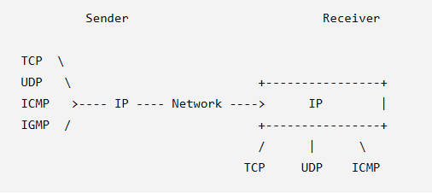

66. To communicate with a remote host, a mobile host goes through three phases: agent discovery, registration, and data transfer. Draw the time diagram.
Answer:
A mobile host communicates with a remote host through three phases: Agent Discovery, Registration, and Data Transfer.
Time Diagram
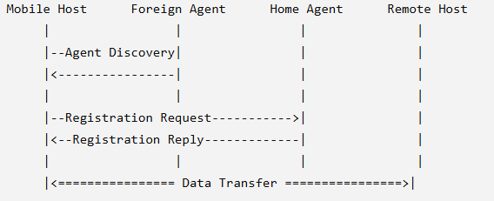

67. Communication involving Mobile IP can be inefficient. Explain the scenarios.
Answer:
Communication in Mobile IP may not always follow the shortest path. This causes two routing inefficiencies.
1. Double Crossing
When the remote host and mobile host are on the same foreign network, packets still travel through the home agent before reaching the mobile host. This causes unnecessary network traffic.
2. Triangle Routing (Dog-Leg Routing)
Packets travel from the remote host → home agent → foreign agent → mobile host instead of directly to the mobile host. This increases delay and reduces efficiency.

